

***FOUR WAY TRAFFIC***

***LIGHT SYSTEM***

**FINAL PROJECT REPORT**

|  |  |
| --- | --- |
| **Group Members:**   1. **Syed Muhammad Huzaifa(21K-4948) (LEADER)** 2. **Talha Shahid (21K-3355)** | **SECTION: BCS-2J**  **Course Code: EL1005**  **Course Instructor: Miss Sadaf Ayesha** |

***Introduction Statement:***

There are many applications for controller circuits. One of them is a highway intersection traffic light. In this project we have design and implement a 4-way traffic light controller that uses pressure activated sensor embedded into the roadway to determine the sequence of light changes used to optimize the flow of traffic.

***Components:***

1. Breadboard
2. Wires
3. Led lights
4. 555 Timmer
5. Cd4017 IC
6. Resisters
7. Diodes
8. Capacitor
9. Shift register
10. 9v Battery

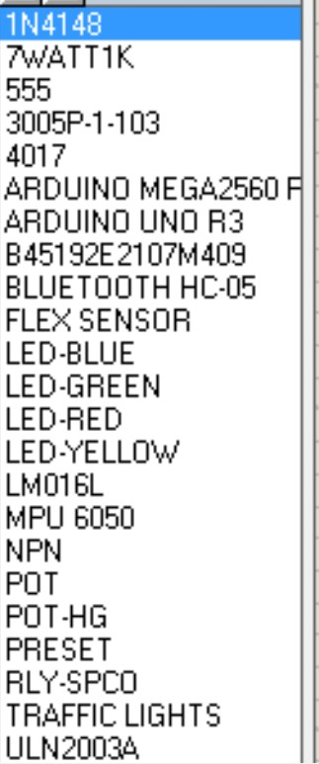

***Circuit Diagram:***

